Standard, Geqo

scripts: V18__Create.sql, V18.1__Insert.sql, test.sql (inner joins)  
  
*geqo off  
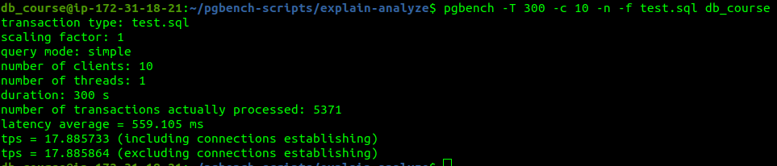

tps = 17.885864  
sql output: output1.txt  
  
*geqo on  
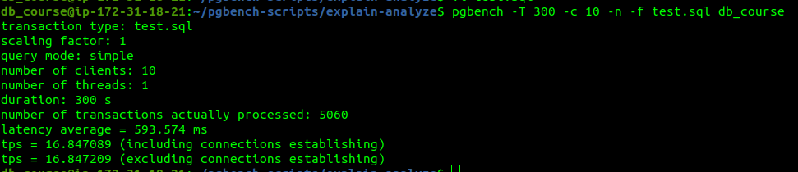  
tps = 16.847209

sql output: output2.txt  
*planning time increased (geqo on)